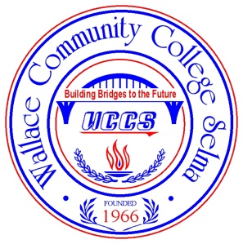
Wallace Community College Selma

RELEASE OF INFORMATION FORM
In compliance with the Family Educational Rights and Privacy Act (FERPA), the policy of WCCS is to refuse to grant third party access to student records without the written consent of the individual student. Any consent given must include the specific records to be released or reviewed and the names of the individuals to whom the information may be released. If you wish to grant permission for your records to be reviewed, please complete the form below.

Student Name________________________________________________ Student #___________________________________

I request the following records be released:

_____ All of my student records

_____ Academic Records
(including transcripts; grade appeals; academic status; advising; Admissions Office files, etc.)

_____ Financial Aid Records
(including all financial aid applications, awards and files; balances; fines; and Business Office files, etc.)

_____ Disciplinary Records
(including any disciplinary event or hearing, or other disciplinary action or response)

_____ Other (specify) __________________________________________________________________________________

My student information may be released to the following person or persons:

Name Relationship

___________________________________________ _____________________________________________

_________________________________________ _____________________________________________

_________________________________________ _____________________________________________

_________________________________________ _____________________________________________

_________________________________________ _____________________________________________

_________________________________________ _____________________________________________

Student Signature___________________________________________________ Date______________________________

Note: There will be a service fee for producing photocopies of any records that are requested to copied by the student or by the person to whom the student gives permission to request photocopies.

3000 Earl Goodwin Parkway P O Box 2530 Selma, AL 36701-2530 (334)876-9295

