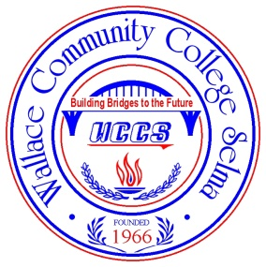
WALLACE COMMUNITY COLLEGE
SELMA
Office of Admission and Records
P O box 2530• Selma, AL • 36702-2530
Phone (334)876-9295 • Fax (334)876-9300

Update Information Form

Name:____________________________________________________________________________________________

Student#:________________________________________________ DOB:___________________________________

Change of Name-Student must provide proof of new name to the Office of Admission and Records for request to be processed.
Acceptable forms include marriage license, social security card with new name, or license with new name.

Previous Name(s):
New Name:

Change of Address, Phone Number, or Email Address
Address:
City: | State: |  | Zip:
Cell Phone: |  | Home Phone:
Email Address:

Change of Emergency Contact
Name:
Relationship: | Phone Number:

Change Semester of Entry
What Semester will you  Enter WCCS: | Fall ________________ | Spring ___________ | Summer ___________

Student Signature:________________________________________ Date:____________________________

OFFICE USE ONLY: Entered By:_________________________ Date:____________________________

